Measure Heath of a people group

Evaluation table: Here are the 10 elements of DNA to measure
PRAYER | COMPASSION | PERSON OF PEACE | DBS | OBEDIENCE | CHURCH GATHERING | DISCIPLE REPLICATION | LEADER DEVELOPMENT | CHURCH  MULTIPLICATION | EVALUATION

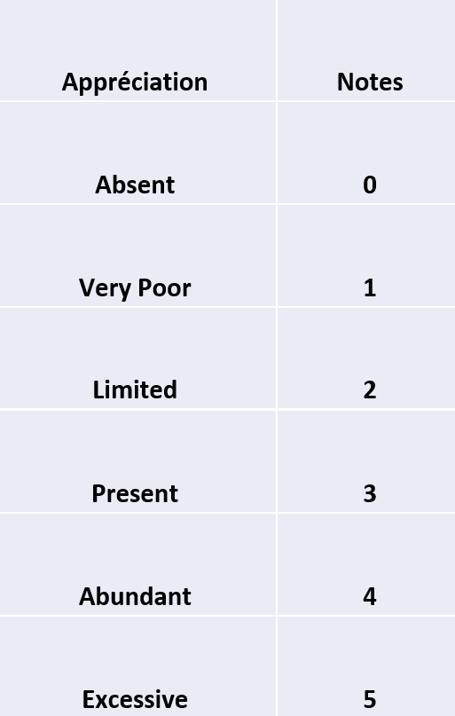
Rating System per DNA element Rating System per people Group
Moyenne | Terme proposé | Sens spirituel
0 –0.5 | Off | Spiritual life is absent; the church functions without divine inspiration.
0.6 –1.5 | Sick | The spiritual DNA is severely altered.
1.6 –2.3 | Fragile | Presence of spiritual life, but unstable and vulnerable to outside influences.
2.4 –3.5 | Alive | The church shows real spiritual health.
3.6 –4.5 | Flourishing | Robust DNA
4.6 –5 | Unbalanced/  Excessive | Excess or deviation: superficial religious hyperactivity, superficial belief, and extreme hypocrisy.

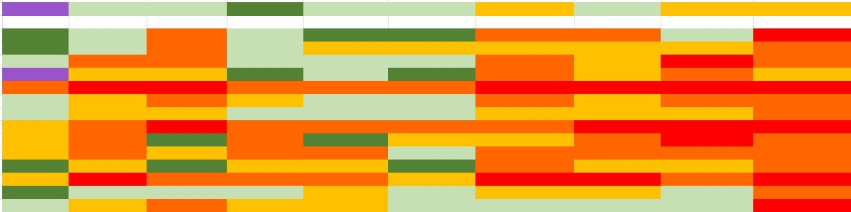
To celebrate and encourage
Need to improve
Need to balance
Acceptable
Call for emergency

